1. plot() - basic scatterplot
2. hist() - basic histogram
3. barplot() - basic barplot
4. pirateplot() – Yarrr package plot shows raw data, descriptive statistics, and inferential statistics in one plot
5. abline() - add lines
6. legend() - add legend
7. pdf(), jpeg(), png() - save file in specific format
8. par(mfrow) - arrange plots in matrix
9. layout() - arrange plots in complex layout

**ggplot**(data = diamonds) +

**geom_bar**(mapping = **aes**(x = cut))

**ggplot**(data = diamonds) +

**geom_histogram**(mapping = **aes**(x = carat), binwidth = 0.5)

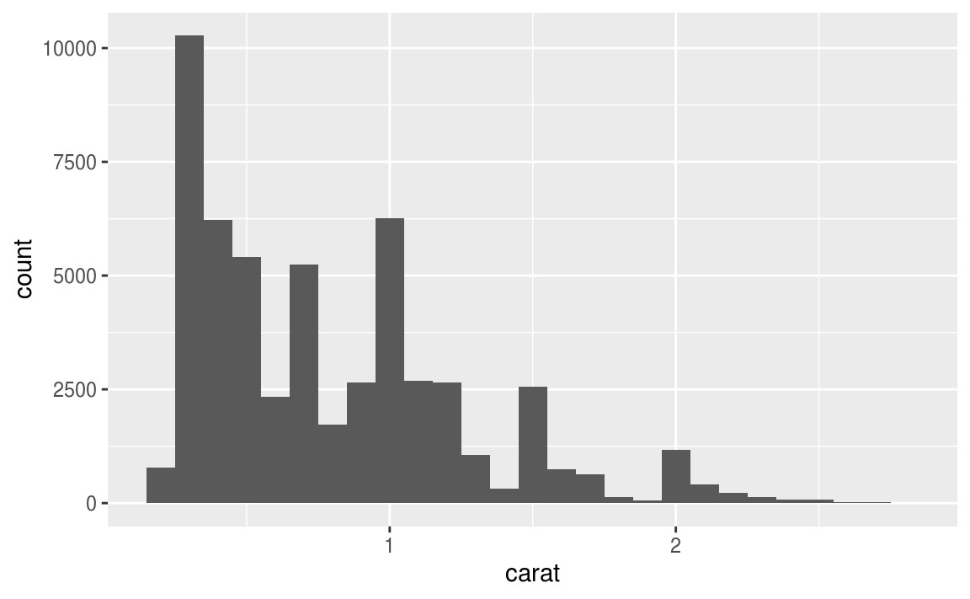

**ggplot**(data = smaller, mapping = **aes**(x = carat, colour = cut)) +

**geom_freqpoly**(binwidth = 0.1)

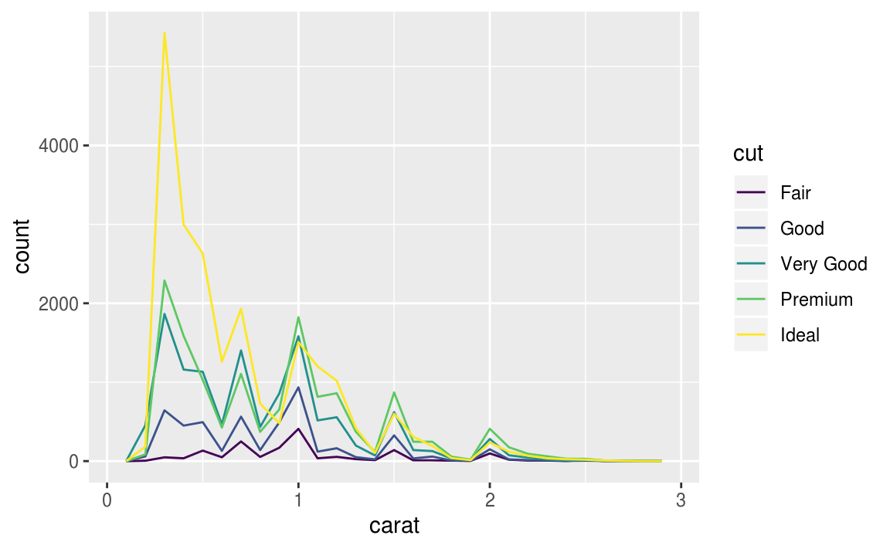

**ggplot**(data = smaller, mapping = **aes**(x = carat)) +

**geom_histogram**(binwidth = 0.01)

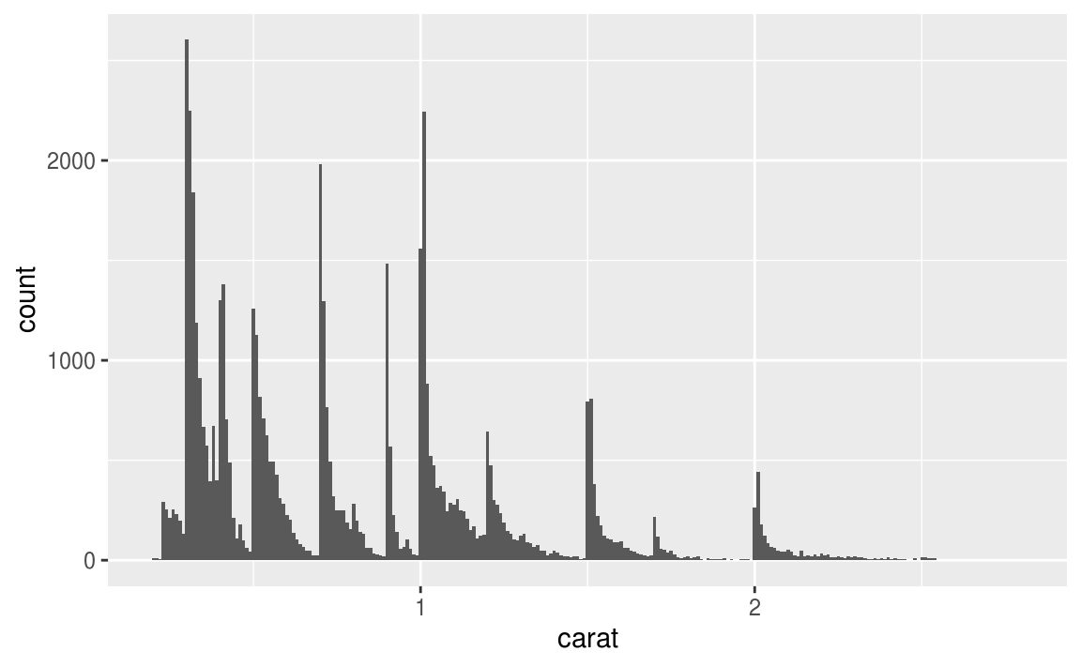

**ggplot**(data = faithful, mapping = **aes**(x = eruptions)) +

**geom_histogram**(binwidth = 0.25)

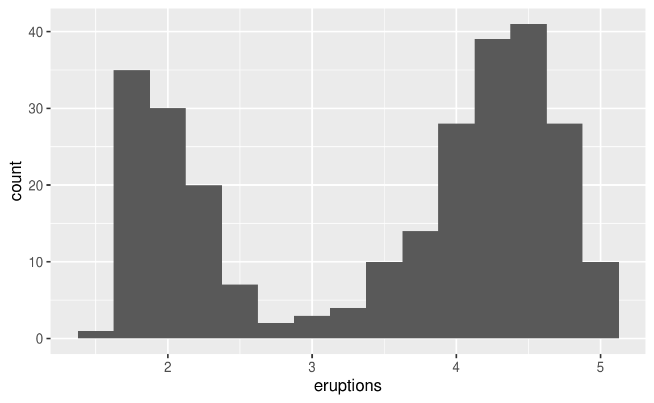

**ggplot**(data = diamonds2, mapping = **aes**(x = x, y = y)) +

**geom_point**()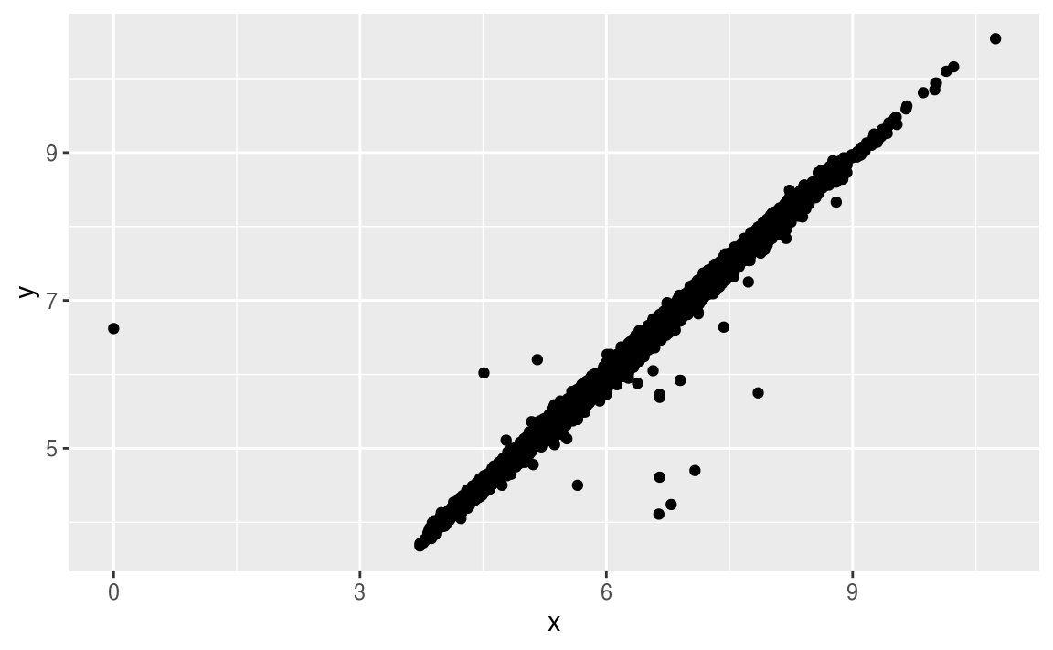

nycflights13::flights %>%

**mutate**(

cancelled = **is.na**(dep_time),

sched_hour = sched_dep_time %/% 100,

sched_min = sched_dep_time %% 100,

sched_dep_time = sched_hour + sched_min / 60

) %>%

**ggplot**(mapping = **aes**(sched_dep_time)) +

**geom_freqpoly**(mapping = **aes**(colour = cancelled), binwidth = 1/4)

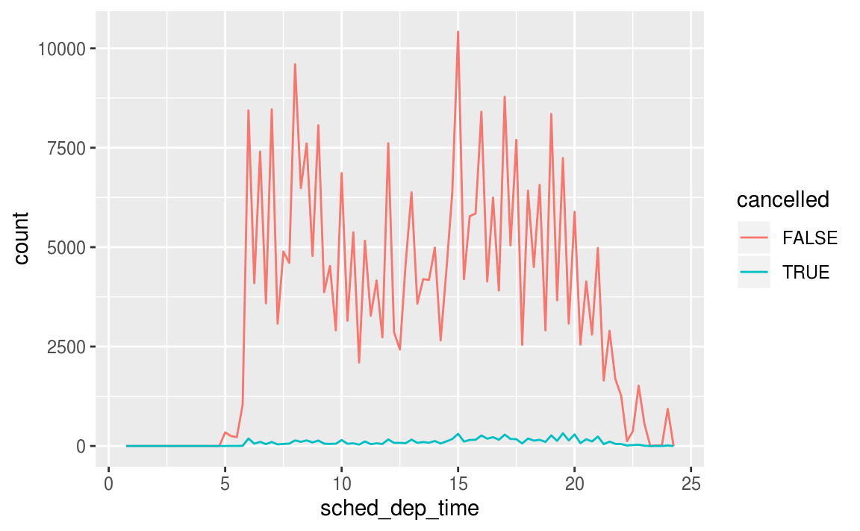

**ggplot**(data = mpg, mapping = **aes**(x = class, y = hwy)) +

**geom_boxplot**()

